**API Postman Screenshot Document**

**Domain: SportShoesApp**

**A SpringBoot API to allow admin to manage admin tasks for SportyShoes company.**

**Author: Prathyusha Kochuru**

**Date: 05/08/2021**

**Database used : MySQL**

**Tools Used: Spring Boot SpringSuite4, PostMan, Swagger**

**Project Git Hub link:** [**https://github.com/prathyushakochuru/SportyShoes-SpringBootAPI**](https://github.com/prathyushakochuru/SportyShoes-SpringBootAPI)

**Weekly GitHub Assignments:** [**https://github.com/prathyushakochuru/CalTechFSDPhase3JavaProjects**](https://github.com/prathyushakochuru/CalTechFSDPhase3JavaProjects)

1. **Admin Controller:**

* **Show all Admin**

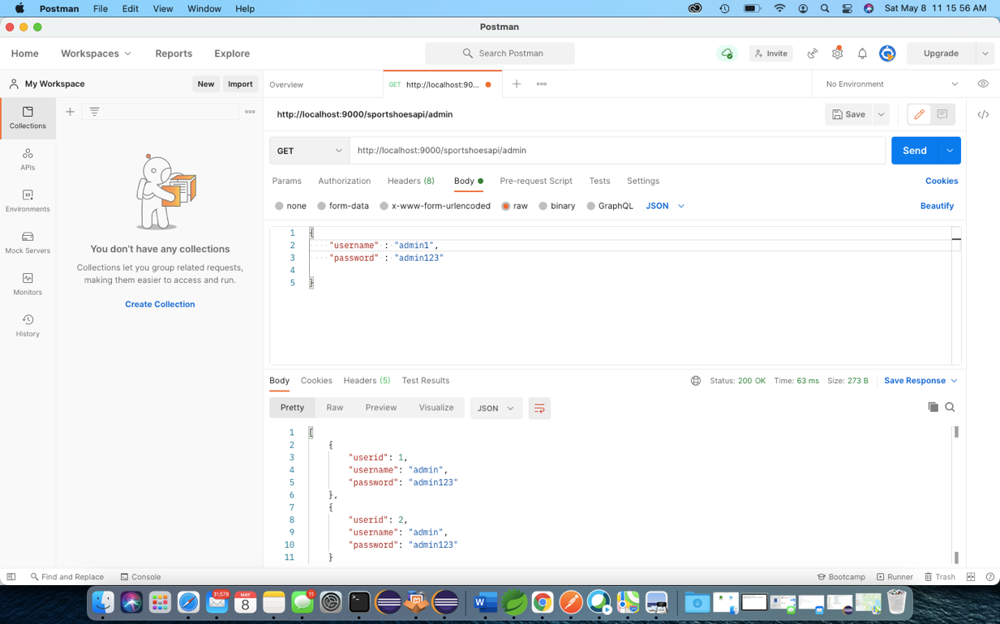

* **Create new Admin**

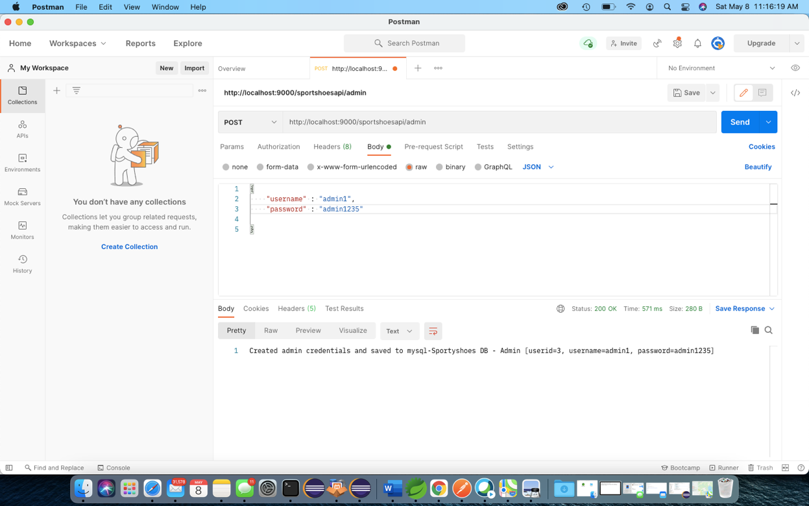

* **Update password**

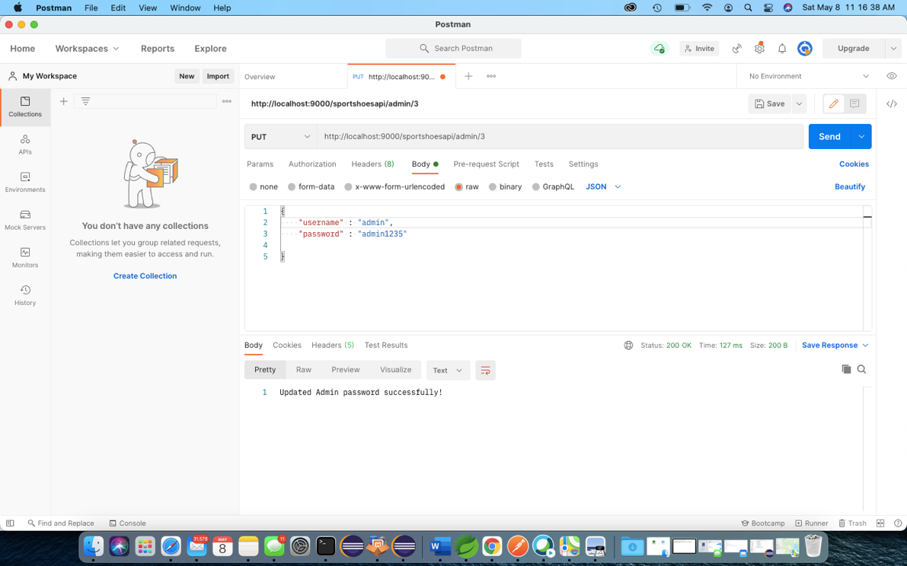

1. **Manage Products**

* **Update product category**

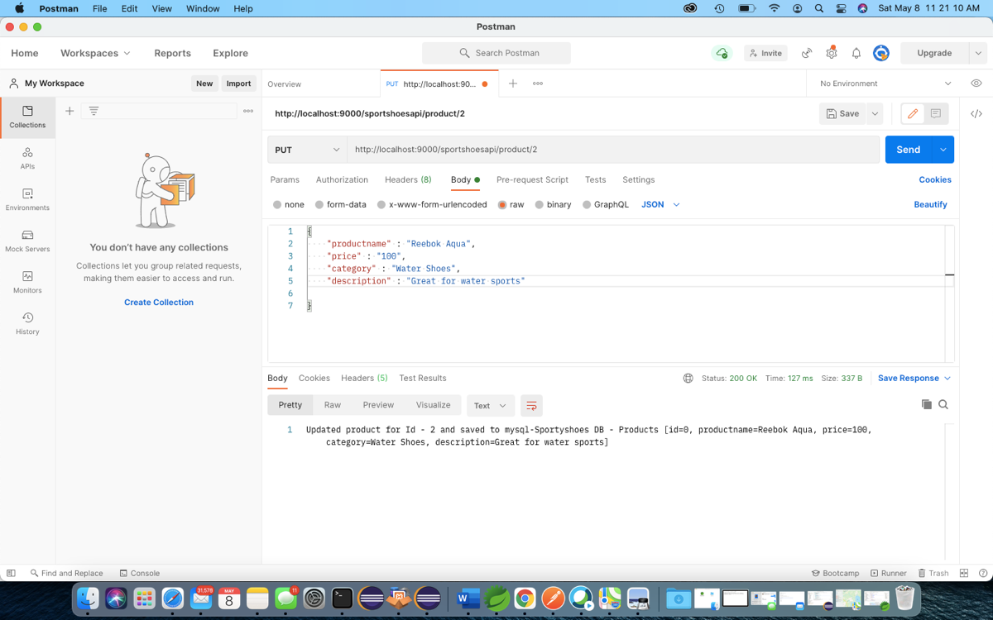

* **Get product by Id**

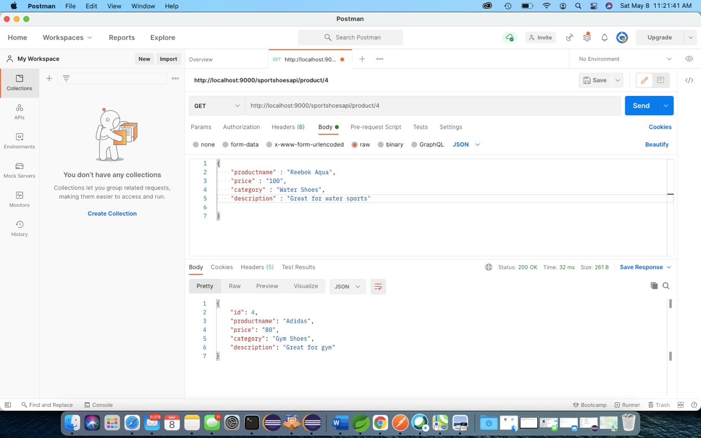

1. **Browse through Users**

* **Show all users**

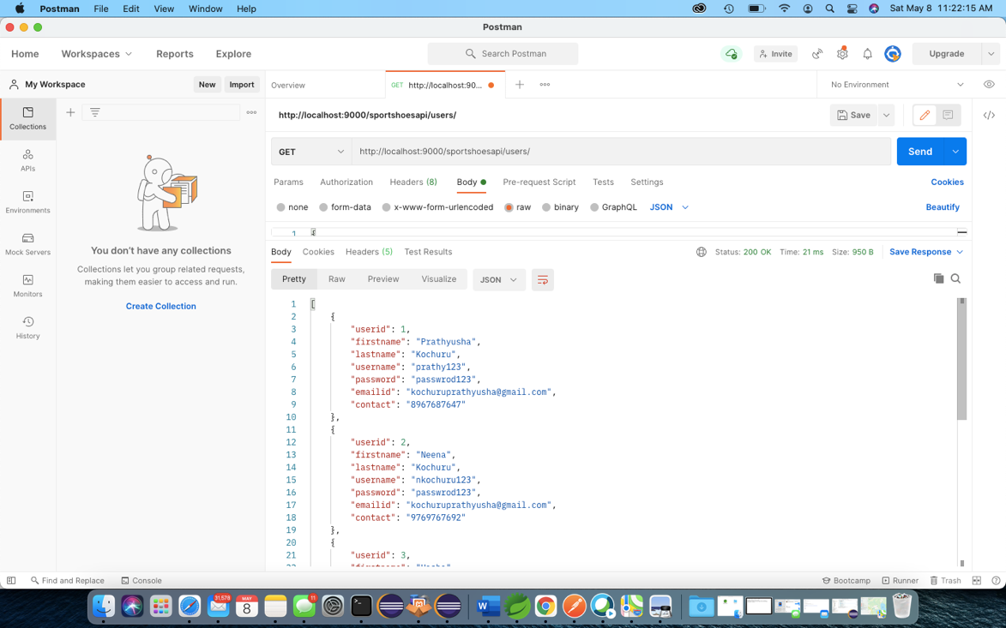

* **Filter users by LastName**

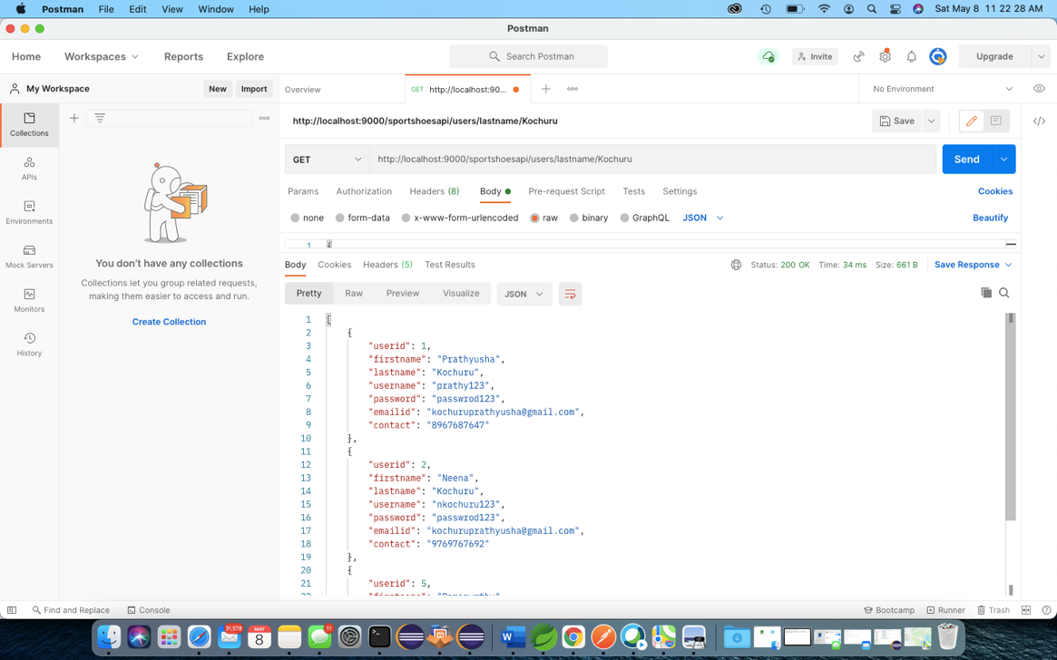

* **Filter users by FirstName**

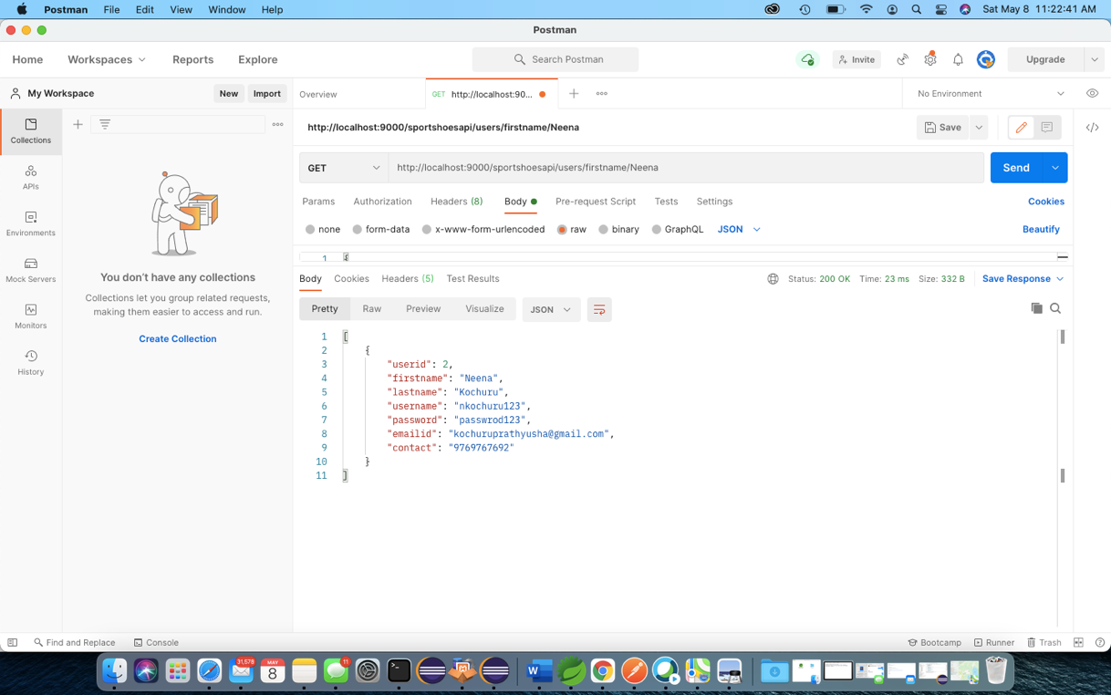

1. **Browse Purchase Reports**

* **Get All Purchase Reports**

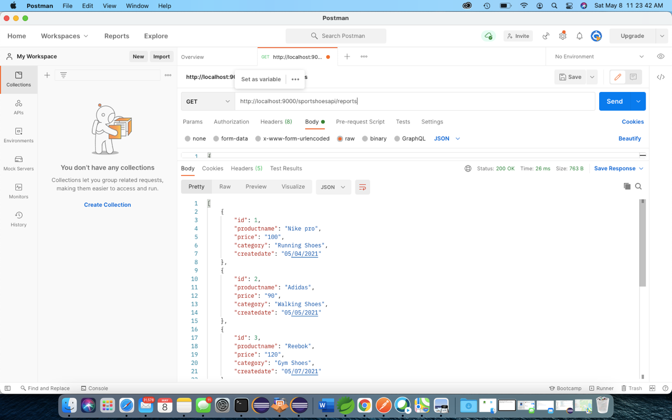

* **Get Purchase Reports by Category**

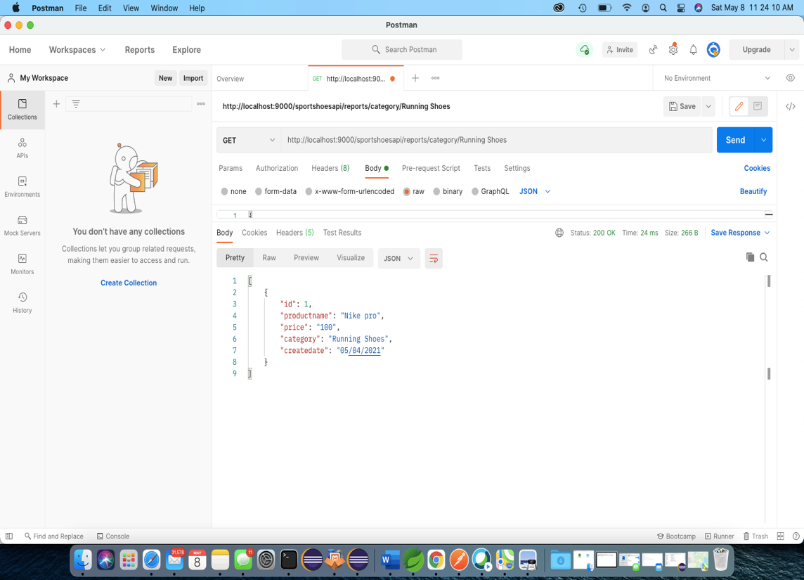

* **Get Purchase Reports by Id**

